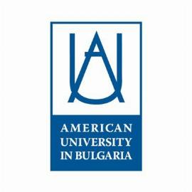
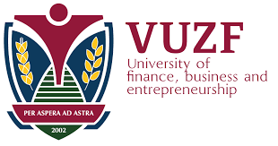
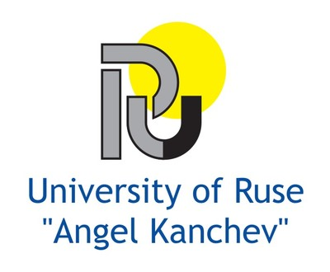
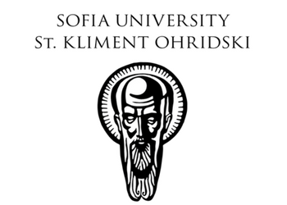
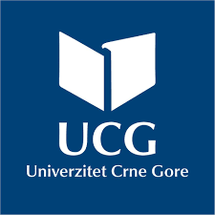
OPEN DAY
Presentation of Bulgarian Universities
10 May 2022
11.00 – 11.15 am Rectorate building | Official Opening  Prof. Dr. Vladimir Božović, Rector  H.E. Ms. Meglena Plugtschieva, PhD,  Ambassador of the Republic of Bulgaria to Montenegro
11.15 am – 15.00 pm University Campus in Podgorica | Presentation of Bulgarian Universities  - Sofia University “Saint Kliment Ohridski”  - University of Economics – Varna  - VUZF University  - American University in Blagoevgrad  - University in Ruse

